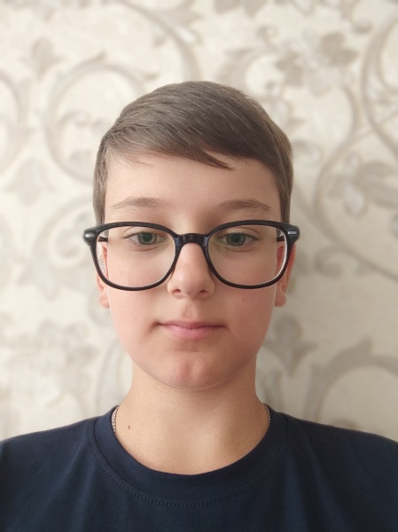**Maxim Chabanov**

**Front-end Developer**

# **Date of birth: 1st September 2009 (11 years)**

**Country of residence: Ukraine**

**E-mail:** [**maxchabanov2009@gmail.com**](mailto:maxchabanov2009@gmail.com)

**Phone: +38(068)9149788**

**Telegram: @MaximChabanov**

**My Skills**

**Html/CSS Jquery**

**Bootstrap Npm**

**Tailwind CSS Figma**

**JavaScript Jira**

**Github/Git**

**About Me**

**Hello! I’m Max. I’m a front-end developer. I am currently working in a small company as a JavaScript programmer. Besides development, I like exercising and cycling. My English level is intermediate.**

**I have an experience of half a year, and I have 3 projects. I would love to take small tasks and bring them to life ;)**

**My Projects**

**My Website**

**05.05.2021** – **07.06.2021 (half a month)**

[**https://maxchabanov.github.io/my-website/**](https://maxchabanov.github.io/my-website/)

Skills used: Html, CSS, JavaScript

**CSS Animations**

**12.04.2021** – **15.04.2021 (3 days)**

[**https://maxchabanov.github.io/bike-animation/**](https://maxchabanov.github.io/bike-animation/)

[**https://maxchabanov.github.io/slide-animation/**](https://maxchabanov.github.io/slide-animation/)

[**https://maxchabanov.github.io/button-animation/**](https://maxchabanov.github.io/button-animation/)

Skills used: Html, CSS, SVG

**Navbar**

**09.07.2021** – **14.07.2021 (5 days)**

<https://maxchabanov.github.io/navbar/>

Skills used: Html, CSS, SVG, responsive layout